## Finite Element Analysis

The FEA analysis was done in FEMAP with NX NASTRAN v10.3 because it allows for the easy import of Soildworks assemblies and its ability to recognize features and surfaces.

### Fuselage

The fuselage of any aircraft needs to withstand several different loads. However, in tandem wing aircraft it needs to specifically withstand the torsion forces applied by the canard and aft wings. These forces are a direct result of the difference in pressures along each wing.

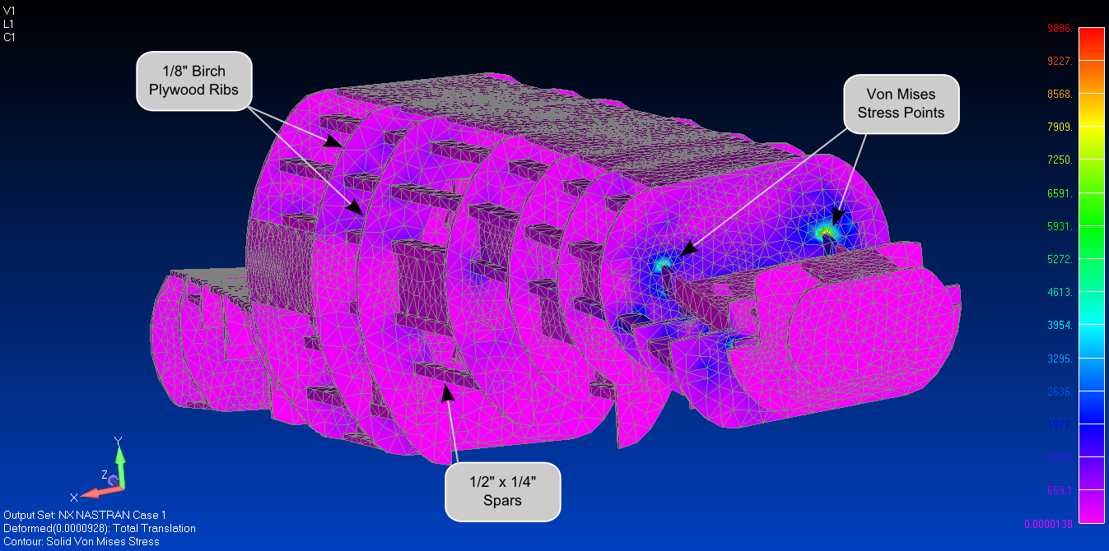

Figure 1: Fuselage Finite Element Analysis (16 ft.lb of torque)

In the FEA simulation above, $16 ft⋅lb$ of torque were applied to the canard wing while the aft wing was held fast. It can be observed that the stress points are located at the interface between the fuselage aft mounting-plate to the first rear rib of the fuselage. Stresses concentrations occur at geometric discontinuities such as interfaces between different components, it can be observed that this is true for our design of the fuselage. Interpreting the results of the simulation it can be observed that the maximum stress value is 9886 Pa which is still much lower than the yield strength of the 1/8” Birch plywood used in the analysis.

### Wings

The analysis of the wings is the next critical component of the aircraft. Any aircraft wing needs to undergo the three point bending test. This test can be summarized as the maximum load a wing assembly can carry at its center with its wing tips fixed before the wing fails. For this analysis a load of 10 pounds was chosen as the maximum load expected for the wing to experience. The results of the analysis show that the critical stress points occur at the leading spar of the wing assembly. Also from the analysis it can be observed that the airfoils don’t carry much stress thus experimenting with other lighter materials is an option to save weight.

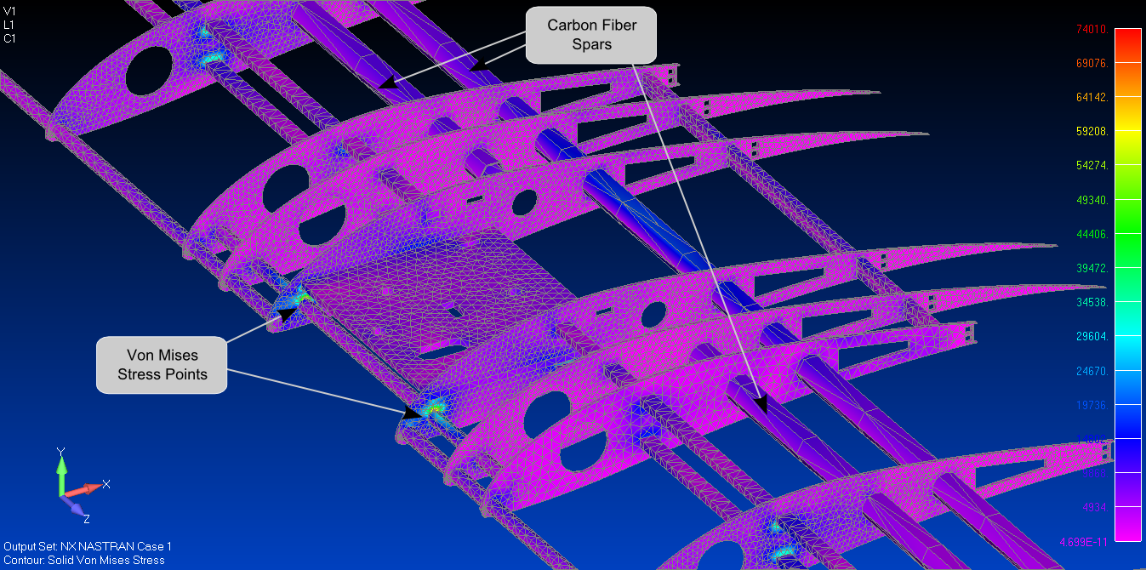

Figure 2: Aft wing Finite Element Analysis

### Landing Gear

Lastly the landing gear was analyzed to insure that during landing it would not buckle or fail leading to a lot of cleanup. The maximum loaded expected to be achieved during a typical landing is 2**G**. The landing gear is made out of carbon fiber with yield strength of 70 GPa.

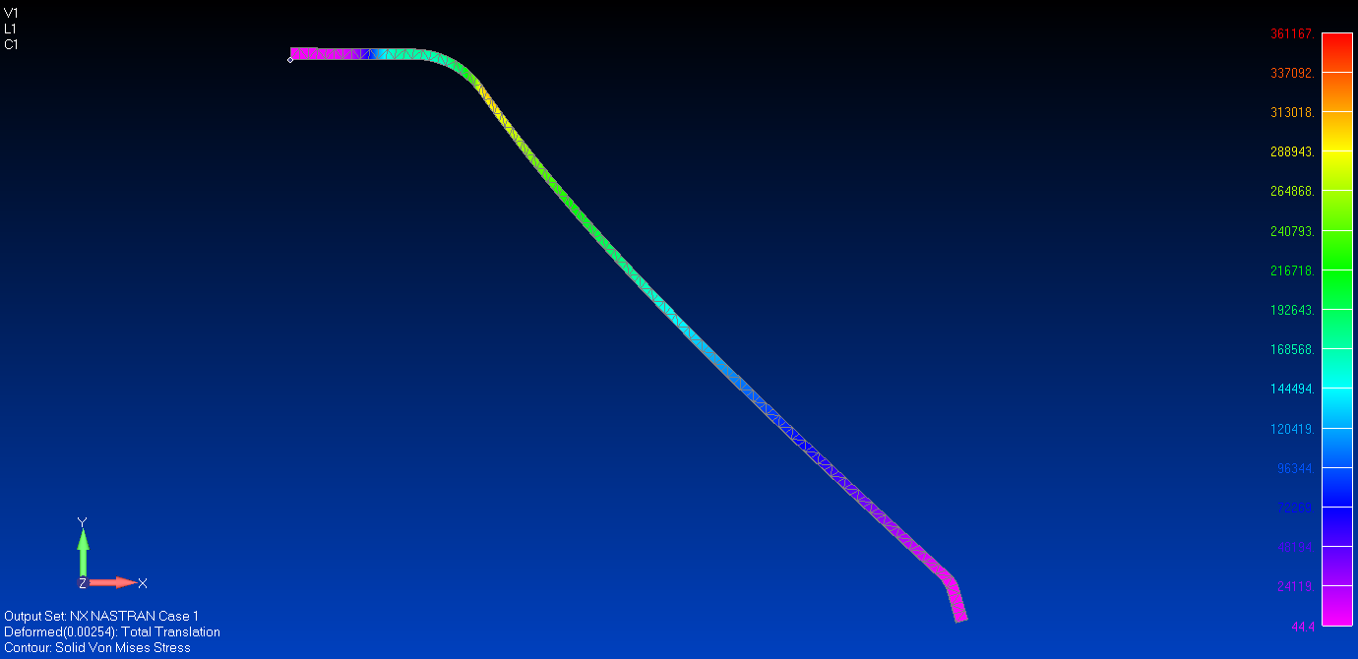

Figure 3: Landing Gear Deflection Finite Element Analysis

The result of the analysis there show that even with a large impart like 2**G** the maximum stress achieved is significantly lower than the yield strength. Thus it is adequate to use this landing gear on the aircraft.